**Health Savings Accounts (HSAs)**

An HSA is a tax-advantaged savings account specifically designed to cover qualified medical expenses. Think of it as a dedicated bucket to set aside pre-tax dollars for healthcare costs. HSAs are most advantageous when paired with a High Deductible Health Plan (HDHP). HDHPs typically have lower monthly premiums but come with higher deductibles (the amount you pay out-of-pocket before insurance kicks in).

**Mechanics of HSAs:**

* **Contributions:** You can contribute pre-tax dollars directly from your pay check through payroll deductions or electronically from your bank account. Employers may also contribute to your HSA.
* **Tax Advantages:** Pre-tax contributions reduce your taxable income, potentially lowering your tax burden.
* **Investment Options:** Some HSAs allow you to invest your contributions for potential tax-free growth. These earnings can significantly boost your healthcare savings over time.
* **Withdrawals:** You can withdraw funds tax-free to pay for qualified medical expenses. Unused funds roll over year after year, accumulating for future needs.

**Benefits of HSAs:**

|  |  |
| --- | --- |
| Benefit | Description |
| Reduced Taxable Income | Pre-tax contributions lead to a lower tax bill. |
| Tax-Free Growth | Investing contributions allows for tax-free growth, maximizing your healthcare savings potential. |
| Tax-Free Withdrawals | Qualified medical expenses are paid for with tax-free dollars, further reducing healthcare costs. |
| Potential for Cost Savings | The combination of lower premiums with an HDHP and tax advantages can translate to significant cost savings, especially for individuals with predictable healthcare needs. |

**Considerations for HSAs:**

* **HDHP Requirement:** To be eligible for an HSA, you must be enrolled in an HDHP. This might not be suitable for everyone, particularly those with frequent or high-cost medical needs.
* **Contribution Limits:** The IRS sets annual contribution limits for HSAs, which vary depending on your HDHP coverage (individual or family).
* **Tracking Qualified Expenses:** It's crucial to maintain accurate records of qualified medical expenses to ensure tax-free withdrawals.
* **Investment Risks:** Investing HSA contributions carries inherent risks. Carefully consider your risk tolerance and investment goals.

**Personal loans**

**Personal Loan:** A non-revolving debt instrument offered by banks, credit unions, and online lenders. Unlike credit cards that allow for ongoing borrowing up to a credit limit, personal loans provide a one-time lump sum that must be repaid in full within a set timeframe.

**Lump Sum:** A single, fixed amount of money disbursed by the lender to the borrower upfront.

**Fixed Monthly Instalments:** Consistent and predictable loan repayments made at predetermined intervals (typically monthly) throughout the loan term.

**Loan Term:** The pre-defined period (usually 1 to 7 years) over which the borrower must repay the borrowed amount along with the accrued interest.

**Unsecured Loan:** A loan that does not require the borrower to pledge collateral (like a car or house) to secure the debt. This is in contrast to secured loans where the borrowed amount is secured by an asset, and the lender can repossess the asset if the borrower defaults on the loan. As a result, unsecured loans often come with higher interest rates compared to secured loans.

**How Personal Loans Work**

The personal loan process follows a defined structure:

**Application:** The borrower submits a formal application to a chosen lender (bank, credit union, online lender).

**Credit Evaluation:** The lender meticulously assesses the borrower's creditworthiness using factors like credit score (a numerical representation of a borrower's credit history and ability to repay debt), income history (demonstrates the borrower's capacity to make loan payments), debt-to-income ratio (DTI, compares a borrower's total monthly debt obligations to their gross monthly income and indicates their ability to manage additional debt), and employment stability (assures the lender of the borrower's continued ability to generate income for repayments).

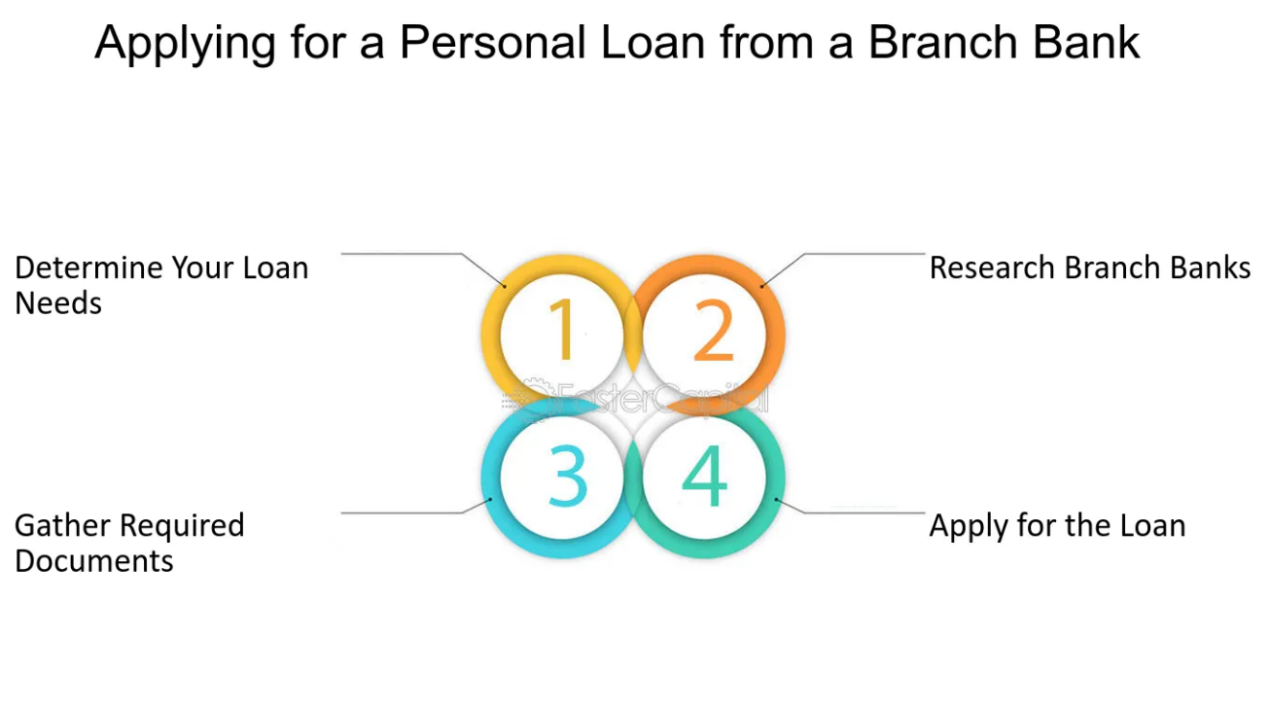

**Approval and Loan Terms:** Based on the credit evaluation, the lender determines the loan amount the borrower qualifies for (maximum amount the lender is willing to lend) and assigns a corresponding interest rate (the cost of borrowing the money, expressed as a percentage of the loan amount).

**Loan Disbursement:** If approved, the lender disburses the approved loan amount (the actual amount of money provided to the borrower after any origination fees are deducted) to the borrower's designated account.

**Repayment:** The borrower repays the loan amount (the principal amount borrowed) along with the accrued interest (the charges levied on the loan over time) in fixed monthly instalments throughout the loan term.

**Interest Rates and Fees**

**Personal Loan Interest Rates:** The annual percentage rate (APR) reflects the total cost of borrowing a personal loan, including the interest rate and any associated fees. These rates can vary significantly depending on the lender, the borrower's creditworthiness (borrowers with better credit scores typically qualify for lower interest rates), and the loan amount (smaller loans may come with higher interest rates). It's crucial to shop around and compare rates from multiple lenders to secure the most favorable terms.

**Origination Fees:** A one-time fee charged by the lender for processing the loan application, covering administrative costs associated with evaluating the borrower's creditworthiness and preparing the loan documents.

**Prepayment Penalties:** A fee imposed by the lender if the borrower pays off the loan early (before the loan term ends). This discourages borrowers from repaying the loan ahead of schedule, as the lender loses out on the potential interest income.

**Common Uses of Personal Loans**

|  |  |
| --- | --- |
| Purpose | Description |
| Debt Consolidation | Combining multiple high-interest debts (credit card debt, medical bills) into a single personal loan with a potentially lower interest rate, simplifying repayment and potentially saving money on interest charges. |
| Home Improvement | Financing renovations or repairs to improve your property's value, functionality, or comfort. |
| Major Purchases | Affording large purchases like cars, appliances, or furniture that may not be feasible with upfront cash. |
| Medical Bills | Covering unexpected or out-of-pocket medical expenses. |
| Special Events | Financing weddings, vacations, or other significant life events. |

**Impact on Credit Score**

Taking out a personal loan can have a temporary impact on your credit score due to the initial hard inquiry during the application process. A hard inquiry refers to a formal request made by a lender to a credit bureau to access a borrower's credit report. While multiple hard inquiries in a short period can negatively affect your credit score, a single hard inquiry for a personal